 **SUD6EC 2025 **

**SUSTAINABLE DEVELOPMENT GOALS EVALUATION CONFERENCE & AWARDS**

**Organized by:** SUDGEC PROJECT, the Presidency, and UNDP Abuja Nigeria

In Conjunction **with:** The Federal Ministry of Budget and Economic Development, the Federal Ministry of Finance, The Federal Ministry of Humanitarian Affairs and Poverty Reduction, the Federal Ministry of labour and Productivity and the Federal Ministry of Information, Abuja Nigeria

Management Office: Room 106, 1st Floor, Federal Secretariat Calabar, Cross River State, Nigeria.

**Website:** sudgecproject.com **Email:** [info@sudgecproject.com](mailto:info@sudgecproject.com) **G** +234 7015991813**0** +234 7075994055



**0 lbom E-Library Complex, along IBB Way, Uyo, Akwa lbom State Nigeria**

**9 November 26th through 28th, 2025**

@ **10:00AM Daily**

# THE INVITATION

**INTRODUCTION/BRIEF HISTORY**

S

UDGEC is a premier international programme that brings together policy makers, development professionals, researchers, and institutions from various sectors to evaluate the progress toward achieving Sustainable

Development Goals (SDGs) around the world.

SUDGEC project has been a leading figure in promoting Sustainable Development Goals (SDGs) around the world with special focus on African countries including Nigeria, dating back to the Millennium Development Goals (MDGs) era. With a rich history spanning over a decade; SUDGEC has established itself as a key player in the assessments and evaluation of development based initiatives within the human society.

Through its annual conferences, project implementation, assessment and evaluation activities, SUDGEC has provided a platform for stakeholders to engage in meaningful discussions, share knowledge, and identify areas for collaboration. The upcoming 2025 conference promises to be an exciting event, with a focus on assessing progress, identifying challenges, fostering collaboration, and recognizing excellence in Sustainable Development and more.

**Awards:** International awards will be presented to deserving individuals and institutions that have made significant contributions to SDGs implementation in Africa and beyond.

**Conference Focus:** The 2025 gathering will focuses on various developmental initiatives, such as education, infrastructure development, youth empowerment, finance, politics, judiciary, legislation, business, leadership and more. By working closely with local communities, all levels of government, and organizations, SUDGEC helps to design and implement projects that address specific development needs.

# THE INVITATION

**(DETAILS)**

T

he project management team, and the developmental partners together with the organizers of the **Sustainable Development Goals Evaluation Conference and Awards (SUDGEC2025)** wish to formally invite you and your institution to

participate in the programme with details as indicated in this invitation package

**A call to Action:** SUDGEC Conferences is a platform for evaluation, knowledge sharing, networking, and recognition of outstanding contributions to development in Africa and beyond. Participants are drawn from various sectors, and papers touching various areas of development will be presented by renowned Scholars from within and outside the continent of Africa. Discussion topics shall include but not limited to:

**Finance and Economy:** Unlocking Africa's economic potential through innovative financing, entrepreneurship and investment.

**Security and Peace Building:** Promoting peace, security, and stability to drive development in Africa.

**Politics and Governance:** Strengthening institutions, promoting good governance, and ensuring accountability to drive development.

**Community Leadership:** Empowering community leaders to drive development and promote social cohesion.

**Education and Skills Development:** Promoting education, skills development, and capacity building to drive human development.

**Health and Well-being:** Improving healthcare outcomes and promoting well-being.

**Environmental Sustainability:** Addressing climate change, conservation, and sustainable resource management to ensure a green and resilient world.

**The Keynote Address**

We are pleased to inform you that provision has been made for you to present a keynote address during the event. Also, your institution will be expected to use this opportunity and highlight your achievements and the impact it has made on the economy and humanity in general.

# THE INVITATION

Your Institution may also wish to take advantage of the conference sponsorship for the, branding, exhibition opportunities of your products and services during the event. (See details/conditionattached).

**Our Request**

By this letter, the organizers wish to request as follows:

1. Mobilize members of your institution under your management to participate in the event.
2. Forward list of participants from your institution selected to attend the event to the organizers at your earliest convenience for proper planning and corporate reception.
3. Submit list of at most three (3) community developmental projects of interest desired for implementation by the project team on partnership basis, and also forward your respond and copy of your keynote address/contribution to the organizers,addressingsameto (the project coordination executive/ conference manager (SUDGEC2025) through contact details above at your earliest convenience, taking the closeness of the event date into consideration.

**Media Coverage:**

The event will be widely covered by selected media houses including but not **limited to:**

CNN, Channel TV,Silver bird TV, AIT, Arise TV, NTA.

**Why Participate?**

By participating in the SUDGEC2025 Conference, you will:

Network with Development Professionals, Connect with experts, policy makers, and practitioners from across Africa and beyond.

**Learn from others:** Gain insights from renowned experts and leaders in the developmental planning and developmental philosophy.

**Panel Discussions:** Development professionals and policy makers will engage in discussions on best practices and lessons learned.

**International Award Conferment:**

Various individuals and corporate institutions that have made significant contributions to development in Africa will be honoured with difference titles of International Awards.

All participants wiII be given certificate of participation.

# THE INVITATION

**CONDITIONS FOR PARTICIPATION**

**Registration:** Participants must register in advance to secure their spot by sending details of participants to the organizers as indicated in this invitation.

**Event fee Payment:** Conference fees must be paid in full before or at the venue

**Conference Fee Payment Categorization:**

* Nigeria Resident Participants - N350,000 (per person)
* International Participants $3,000

(The event fee covers: Conference materials/certificate of participation, food, group photograph, lecture materials and souvenirs).

**Early Bird Conference Payment Rate (Prepayment benefit)**

Before November 101\ 2025-15% discount.

Before November 15th 2025-10% discount on the event fee is available (only for participants who pay early).

Payment on the event date is 100% of the fee above.

**Mode/Direction for Payment:**

**Bank Transfer/Direct Payment** should be made in favour of SUDGEC Project International with thefollowing details below.

**Bank:**

**Account Number:**

TAJ BANK 0012949853



We look forward to receiving you and your team atSUDGEC 2025.

# THE SPONSORSHIP

**CONFERENCE SPONSORSHIP/EXHIBITION OFFER DURING THE SUDGEC2025**

We are excited to invite you to participate in the Sustainable Development Goals Evaluation Conference & Awards (SUDGEC2025) as a sponsor/exhibitor/business branding partner. This premier international event brings together Policy makers, Development Professionals Researchers, and Institutions from various sectors to evaluate progress towards achieving the Sustainable Development Goals' (SDGs) in Africa and other continents.

**Business Branding Opportunities:**

We offer various business branding opportunities,including:

**Conference Venue Branding:** Brand your organization at the conference venue, including exhibition spaces, conference rooms, plenary halls, almanac reflection, projecting shoot during lectures, souvenir program, back drop flex banner display, general media promo, signpost/ location, advert bill board placement advert.

**Exhibition Booths:** Showcase your products and services at our exhibition booths, which will be strategically located in high-traffic areas.

**Sponsorship Opportunities:** Partner with us as a sponsor and receive recognition as a platinum, gold, or silver sponsor.

**Souvenir Program:** Advertise in our souvenir program, which will be distributed to all conference participants.

**Digital Platforms:** Reach a wider audience through our digital platforms, including social media, email marketing, and online advertising.

**Places to Brand and Exhibit:**

We offer various places to brand and exhibit, including:

**Exhibition Halls:** Showcase your products and services in our exhibition halls, which will be visited by conference participants.

**Conference Rooms:** Brand your organization in our conference rooms, where key discussions and meetings will take place.

**Plenary Halls:** Reach a wider audience by branding your organization in our plenary halls, where keynote addresses and panel discussions will take place.

**Networking Areas:** Showcase your products and services in our networking areas, where conference participants will gather to network and socialize.

# THE SPONSORSHIP

**Digital Platforms:** Brand your organization on our digital platforms, including our website, social media, and email marketing campaigns.

**Benefits of Business Branding:**

By participating in the SUDGEC2025 Business Branding Opportunities,your organization will:

* Increase visibility and credibility in the development sector.
* Reach a targeted audience of development professionals, policymakers, and researchers. Showcase your products and services to a wider audience.
* Network with potential partners, clients, and stakeholders.

**Packages and Pricing:**

We offer various packages and pricing options, including:

**Platinum Sponsor:** Nl00 Million forgroupA-NS0 Million for group B-N25 Million for Group C-NlS million for group D (Includes exhibition space, branding opportunities, and recognition as a platinum sponsor)

**Gold Sponsor:** NS0 Million for group A- N25 million for group B - NlS million for Group C- NS million for group D(includes exhibition space and branding opportunities).

**Exhibition Space:** Size A-NS0,000,000,Size B- N25,000,000, Size C- N 10,000,000 (per booth).

**Early Bird Sponsorship/Business Branding Payment Rate {Prepayment)**

1Before October 30 \ 2025-15% discount.

Before November 15th 2025-10% discount on the conference fee (for participants who pay early).

**Mode/Directionfor Payment:**

**Bank Transfer/Direct Payment** should be made in favour of SUDGEC Project International with the following details below.

**Bank:** TAJ BANK

**Account Number:** 0012949853

**Deadline for Submission:**

Please submit your acceptance for sponsorship/business branding opportunities on or before

1

November 15 \ 2025. Late submissions may not be accepted.

**Contact Information:**

If you have any questions or would like more information, please contact us early enough to enable us serve you better.

We look forward to partnering with you at SUDGEC2025.

# THE AWARD CONFERMENT I

**Nomination for Sustainable Development Goals international Awards**

We are pleased to inform you that you have been nominated for the **United Nations' Sustainable Development Goals Evaluation Awards.** This prestigious recognition is a testament to your outstanding contributions to the advancement of the Sustainable Development Goals (SDGs) and the economy of your beloved country in general.

You will be conferred with this prestigious award during the upcoming Sustainable Development Goals Evaluation Conference and Awards (SUDGEC2025). The award conferment will take place on 2nd day being November 25th 2025, during the SUDGEC2025 at lbom E-Library, along IBB Way, Uyo, Akwa lbom State, Nigeria, scheduled to hold from November 26th through 28th 2025 at 10:am each day, but registration of all participants/award nominees must be made, and all details of both the award recipients and the witnesses submitted earlier for proper preparation ahead the conferment.

This event promises to be a grand gathering of over 2000 outstanding personalities from across Africa and beyond.

To facilitate the award process, please find and complete the attached Nominee's Information Form, together with Award Witness Form.

We kindly request that you complete these two forms and return them on time as directed to enable the organizers prepare towards a grand reception of your distinguished person, witnesses and members of your entourage, taking the closeness of the event date into consideration.

Congratulations once again on your nomination.

We look forward to celebrating your achievements at the upcoming conference and award ceremony.

Please do not hesitate to contact us if you require any additional information.

## AWARD NOMINATION FORM I

**United Nations' Sustainable Development Goals International Awards (Nominee's Information to be completed with black ink)**

Name:...................................................................................................................................

Title:......................................................................................................................................

Organization:.........................................................................................................................

Category of Award:................................................................................................................

**Acceptance and Participation:**

**Nominee's Statement:** l, hereby

accept the nomination for the Sustainable Development Goals' International Awards.

**Witnesses:**

**Number of Witnesses:** 3 to 20 persons can witness the award conferment.

**Event Participation Fee for Witnesses:**

**3-10 Witnesses:** (90% of the fixed event fee)

**10-20witnesses:**85% of the fixed event fee.

**Witness Details:** (Please attach a separate sheet with witness details/additional information.

**Citation and CV:**

Brief Citation: 200 words citation highlighting achievements and contributions.

**Comprehensive CV:** 2 page CV outlining professional experience and accomplishments.

**Submission Deadline:**

**Return completed Form:** before November 15th 2025. Early completion/return of form/details will be highly appreciated.

**Contirmation:**

**Confirmation Email: to be** Sent upon receiving nomination form/details from the nominee.

**Payment Evidence:**

# THE AWARD CONFERMENT I

**Event Registration: pis.** Attach payment/transaction slip as evidence while returning this form.

**Signature:**

Nominee's Signature: Confirming acceptance and commitment to participate. Date: Ensure timely submission and completeness, please.

**OFFICIAL USE ONLY:**

**Verification:** Completed form verified by...............................................................................

**Comment:** By the conference and award manager.

**Date:...............................................................................................................**

**Signature:.......................................................................................................**

# AWARD WITNESS FORM I

1. Name/Title:......................................................................................................................

Address/Email:............................................./Tel:...........................................................

1. Name/Title:......................................................................................................................

Address/Email:............................................./Tel:...........................................................

1. Name/Title:......................................................................................................................

Address/Email:............................................./Tel:......................................................... **.**

1. Name/Title:......................................................................................................................

Address/Email:............................................./Tel:...........................................................

1. Name/Title:......................................................................................................................

Address/Email:............................................./Tel:......................................................... **.**

1. Name/Title:......................................................................................................................

Address/Email:............................................./Tel:......................................................... **.**

1. Name/Title:......................................................................................................................

Address/Email:............................................./Tel:...........................................................

1. Name/Title:......................................................................................................................

Address/Email:............................................./Tel:......................................................... .

1. Name/Title:......................................................................................................................

Address/Email:............................................./Tel:......................................................... **.**

1. Name/Title:......................................................................................................................

Address/Email:............................................./Tel:...........................................................

1. Name/Title:......................................................................................................................

Address/Email:............................................./Tel:......................................................... .

# AWARD WITNESS FORM I

1. Name/Title:......................................................................................................................

Address/Email:............................................./Tel:...........................................................

1. Name/Title:......................................................................................................................

Address/Email:............................................./Tel:......................................................... .

1. Name/Title:......................................................................................................................

Address/Email:............................................./Tel:......................................................... **.**

1. Name/Title:......................................................................................................................

Address/Email:............................................./Tel:...........................................................

1. Name/Title:......................................................................................................................

Address/Email:............................................./Tel:...........................................................

1. Name/Title:......................................................................................................................

Address/Email:............................................./Tel:......................................................... .

1. Name/Title:......................................................................................................................

Address/Email:............................................./Tel:...........................................................

1. Name/Title:......................................................................................................................

Address/Email:............................................./Tel:...........................................................

1. Name/Title:......................................................................................................................

Address/Email:............................................./Tel:......................................................... **.**

1. Name/Title:......................................................................................................................

Address/Email:............................................./Tel:...........................................................

 SUD:icEC 2025 

**SUSTAINABLE DEVELOPMENT GOALS EVALUATION CONFERENCE 8c AWARDS**

**Organized by:** SUDGEC PROJECT, the Presidency, and UNDP Abuja Nigeria

**In Conjunction with:** The Federal Ministry of Budget and Economic Development, the Federal Ministry of Finance, The Federal Ministry of Humanitarian Affairs and Poverty Reduction, the Federal Ministry of Labour and Productivity and the Federal Ministry of Information, Abuja Nigeria

Management Office: Room 106, 1st Floor, Federal Secretariat Calabar, Cross River State, Nigeria.

**Website:** sudgecproject.com **Email:** [info@sudgecproject.com](mailto:info@sudgecproject.com0)**[0](mailto:info@sudgecproject.com0)** +234 7015991813**0** +234 7075994055

**CATEGORIES OF SUSTAINABLE DEVELOPMENT INTERNATIONAL AWARDS 2025**

1. **SDGs Champion Award:**

Honouring individuals or institutions that have made significant contributions to achieving the Sustainable Development Goals (SDGs).

1. **Green Economy Award:**

Recognizing innovative approaches to sustainable economic development.

1. **Climate Action Award:** Honouring efforts to reduce carbon emissions and mitigate climate change.

**EDUCATION AND HUMAN CAPITAL DEVELOPMENT**

1. **Education for All Award:**

Recognizing initiatives that promote access to quality education.

1. **Innovation in Education Award:**

Honouring innovative approaches to education and learning.

1. **Human Capital Development Award:**

Recognizing efforts to develop skills and capacities for economic growth.

**HEALTHCARE AND WELLNESS**

1. **Healthcare Innovation Award:**

Honouring innovative approaches to healthcare deliveries.

1. **Wellness and Nutrition Award:**

Recognizingefforts to promote healthy lifestyles and nutrition.

1. **Health Equity Award:**

Honouring initiatives that promote access to healthcare for less privileged communities.

**ECONOMIC DEVELOPMENT AND POVERTY REDUCTION**

1. **Poverty Reduction Award:**

Recognizing efforts to reduce poverty and inequality.

1. **Economic Empowerment Award:**

Honouring initiatives that promote youth and economic development.

1. **Innovation and Entrepreneurship Award:**

Recognizing innovative approaches to entrepreneurship and job creation.

**ENVIRONMENTAL CONSERVATION AND MANAGEMENT**

1. **Environmental Conservation Award:**

Honouring efforts to conserve and protect the environment.

1. **Waste Management Award:**

Recognizing innovative approaches to waste management and reduction.

1. **Climate Resilience Award:**

Honouring initiatives that promote climate resilience and adaptation.

**GOOD GOVERNANCE AND HUMAN RIGHTS**

1. **Good Governance Award:**

Recognizing efforts to promote transparency, accountability, and good governance.

1. **Human Rights Award:**

Honouring initiatives that promote and protect human rights.

1. **RuleofLawAward:**

Recognizing efforts to promote the rule of law and justice.

**SCIENCE, TECHNOLOGY, AND INNOVATION**

1. **Science and Technology Award:**

Honouring innovative approaches to science, technology, and innovation.

1. **Digital Innovation Award:**

Recognizing efforts to promote digital innovation and entrepreneurship.

## AWARD NOMINEES/EXPECTED VIPs/

WHO IS WHO AT SUDGEC2025 LIST ONE (I)

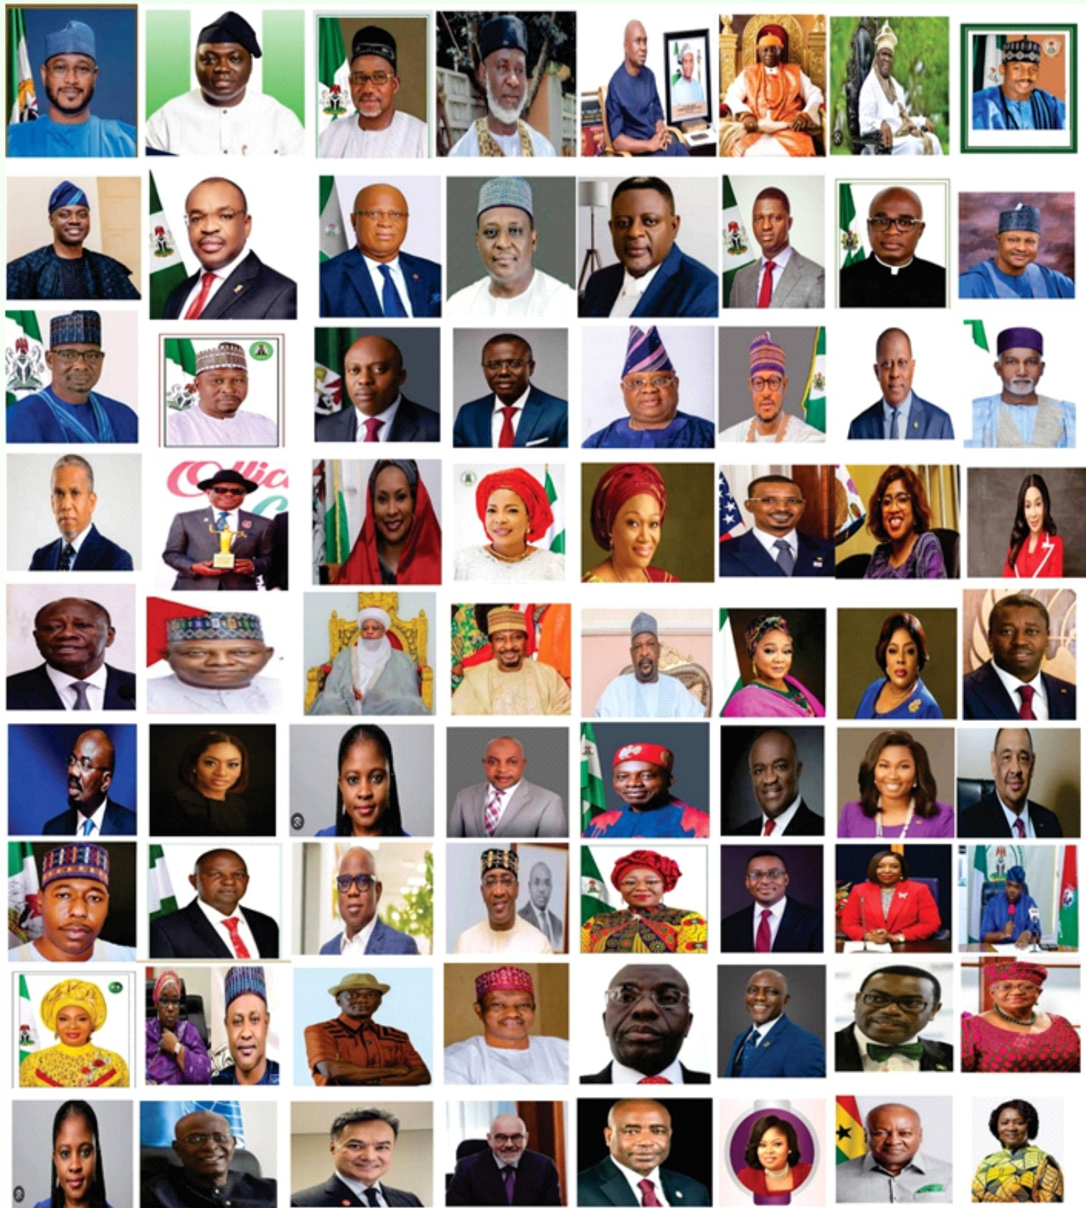

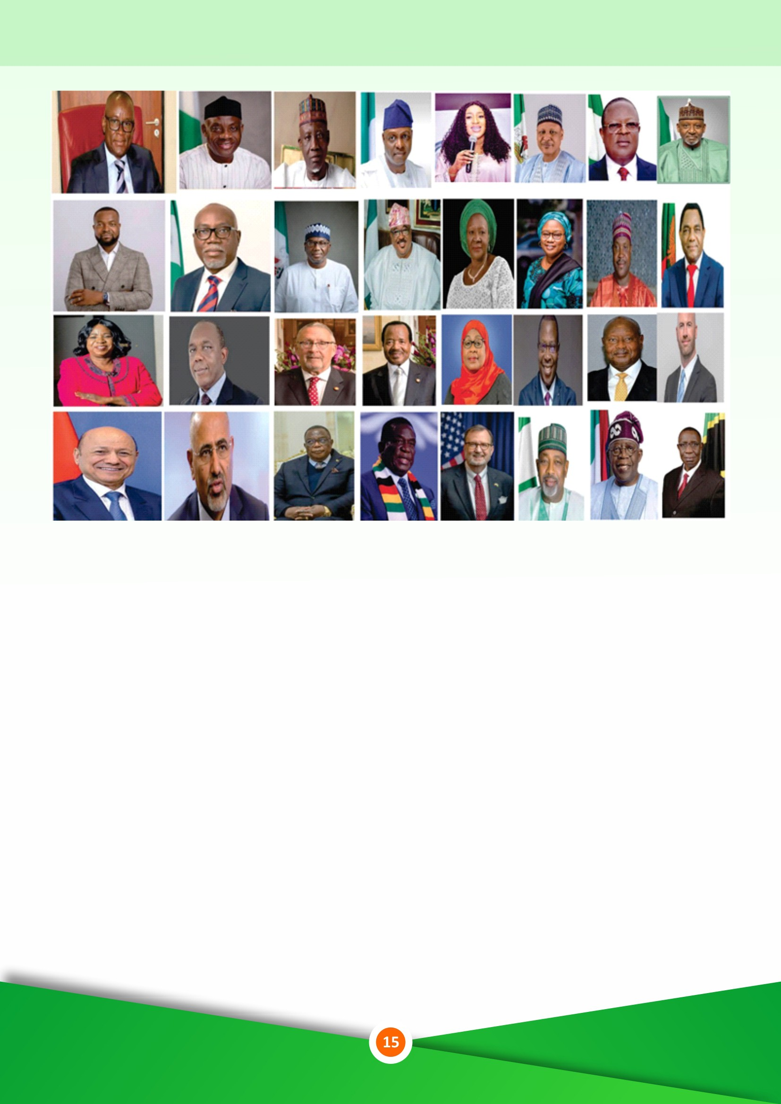

**TEN OUT OF THE TWENTY HOTEL ACCOMMODATION RECOMMENDED WITHIN UYO CAPITAL CITY FOR SUDGEC CONFERENCE PARTICIPANTS WITH CONTACT DETAILS**

**(PLEASE CONTACT ANY OF THE HOTELS BELOW FOR YOUR BOOKING)**

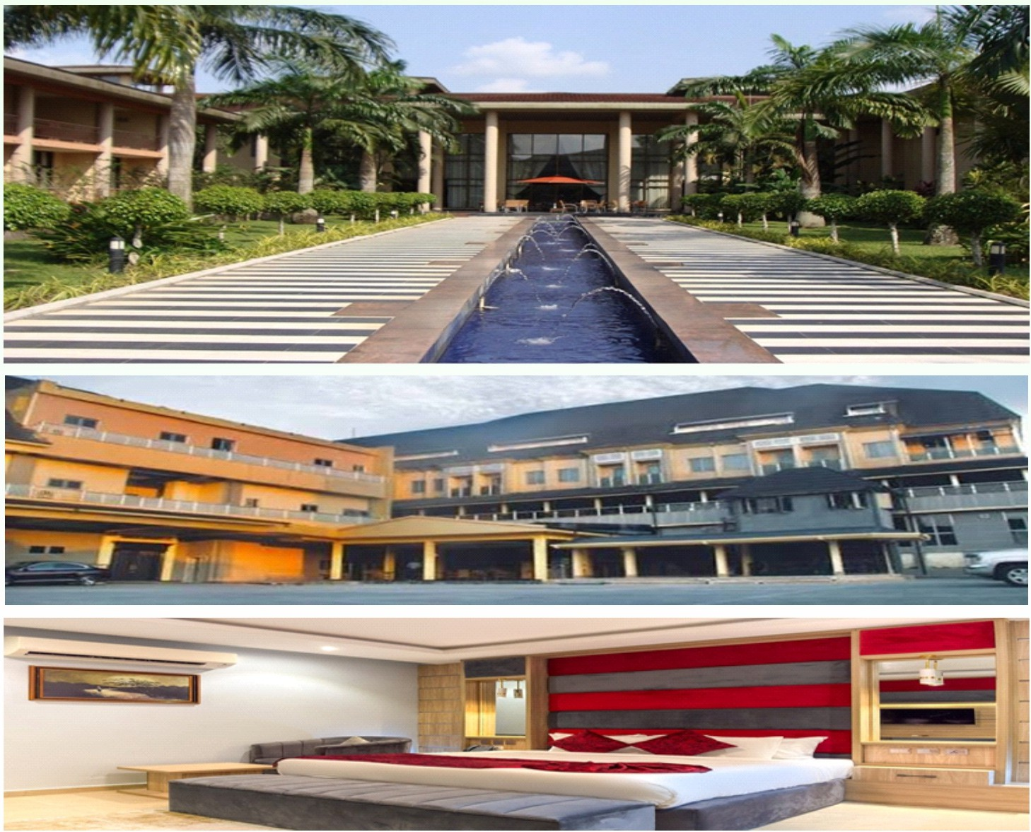

1. Iborn Hotel and Golf Resort-Nwaniba Road Uyo, Tel Phone No:+234808057411
2. Ceedapeg Hotels Unit B, Plot 29-34, Chief Odiong/ Donald Etiebet Street Ewet Housing Uyo Tel Phone No.+2349033491703
3. Watbridge Hotel off IBB Way Uyo TEL Phone No. +2349038151033
4. Fresh Spring Hotels and Towers, No. 49 Akpa Ube St. Off IBB Way Uyo, Tel: +2347033598551
5. Lahana Hotel, No. 5 Bassey Esau St., off Aka ltiam St. Uyo, Tel: Phone No, +2348106160004
6. Dveua Hotels Opposite Pepsi Junction, Abak Rd. Uyo, Tel: Phone No, +2349013831243
7. Monty Suites No. 37 general EdetAkpan Avenue (4 Lane) Uyo. Tel: +2347038091700
8. Rosmohr Hotels A 126, C49 Ewet Housing Estate Uyo, Tel: Phone No, +2348163897557
9. RBIT Hotel and Suites, Plot 55 Unit C, Ewet Housing Estate Uyo, Tel: Phone No.+2347089569339

Uranus Hotel, No. 36 B Aka ltiam Street off Nsikak Edouk Avenue Uyo, Tel: Phone No. 2347087568895